**Stakeholders Engagement Plan :**

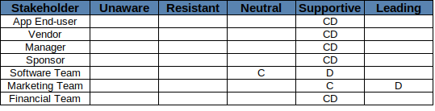

1- the marketing team should persuade the **end-user** through marketing campaigns about how useful the app is to them until they support the team by sending feedback reviews, bug reports and suggestions.

2- the marketing team should persuade the **Vendor** about how much they would profit from being a part of this new technological revolution through using these apps to increase their sales until they support the team by sending reviews, bug reports and suggestions.

3- the PM should write a clear business plan with the ROI to persuade the **Manager** to support the team in the project, and the same for the **Financial team** who will also be persuaded to do more financial research on the project.

4- the **Sponsor** should be kept into the light with the frequent reporting of the progress of the project and how efficient is the team in handling risks and solving issues.

5- The **Software Team** will be the hardest one to persuade because this is like a refactor to the old discount card project so the new updates will mean more work for them. So the PM should persuade them that this new project will improve company’s KPIs and will make them more valuable and they might get a pay raise. Same way of persuation for the **marketing team**, as they will be contributing in a bigger project with a better & easier idea to market.

**Stakeholders Communication Plan:**

